

K.R. Mangalam University
School of Engineering & Technology

Analysis and Design of Algorithms
Capstone Assignment

Delivery Route Optimization System

Submitted by: Submitted to:
Name:sakshi singh Dr.Aarti Sangwan
Roll no. : 2401420042
Program: Btech-CSE (Data Science)
Section – A

Task 1: Input modeling & constraint setup

Deliverables
- Graph + parcel + vehicle data

Code-
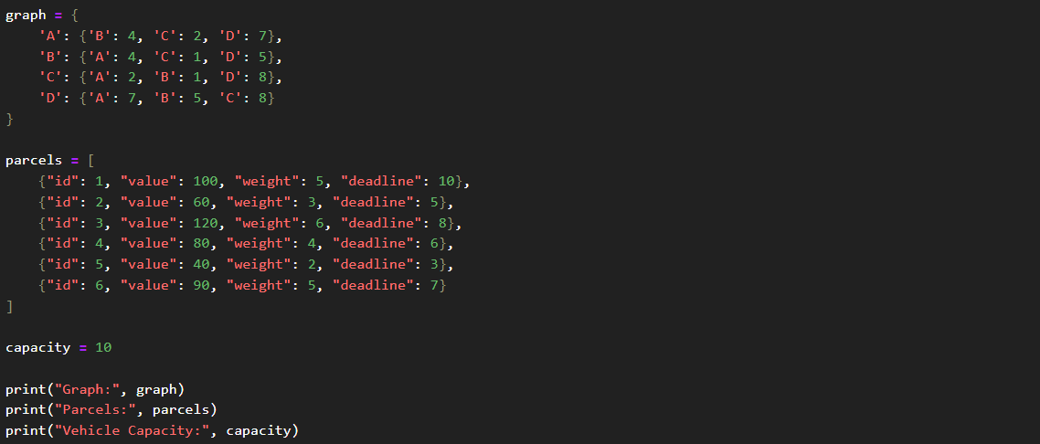

Output-

Task 2:Recurrence-based route cost function

Deliverables
- Recursive function output

Code-
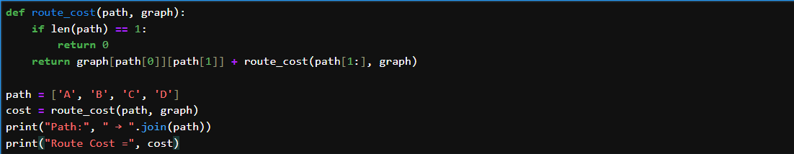

Output-

Task 3:Greedy + DP for delivery planning

Deliverables
- Parcel selection + time window validation

Code-
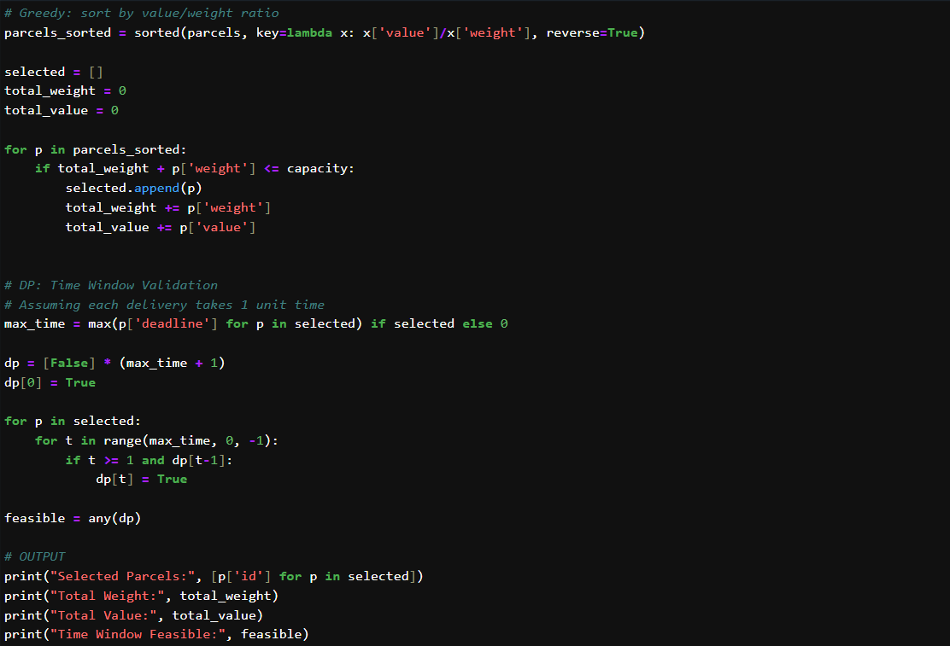

Output-

Task 4:Graph algorithms for route building

Deliverables
- Dijkstra/MST result and analysis

Code-
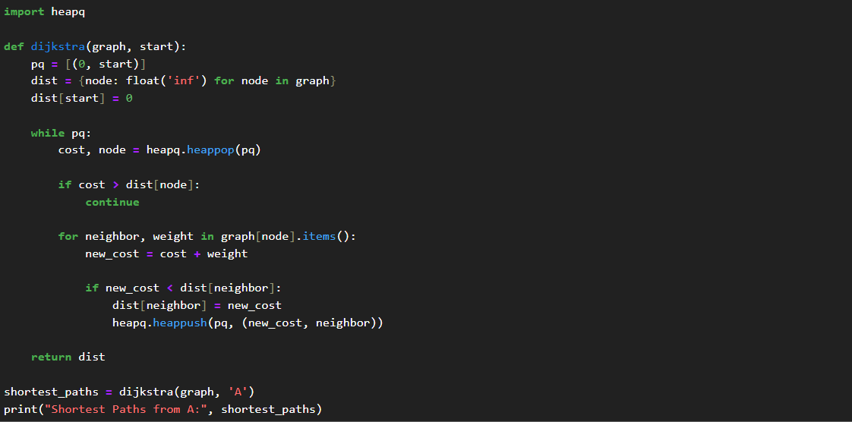

Output-

Task 5:TSP implementation

Deliverables
- Route + total distance

Code-
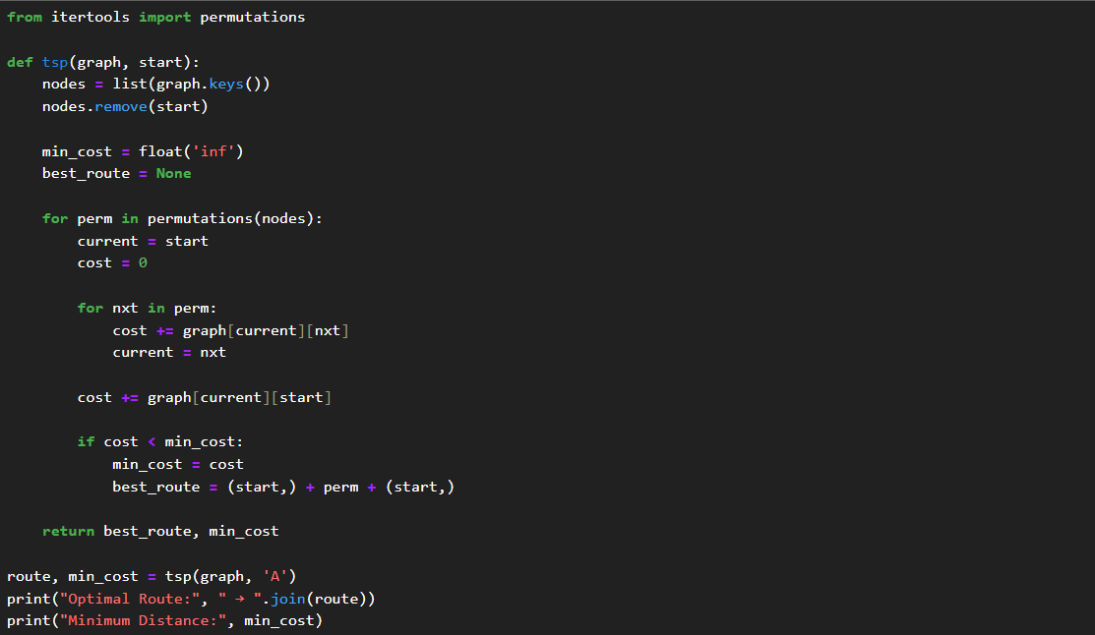

Output-

Task 6:Profiling and visualization

Deliverables
- Plots for performance and route

Code-
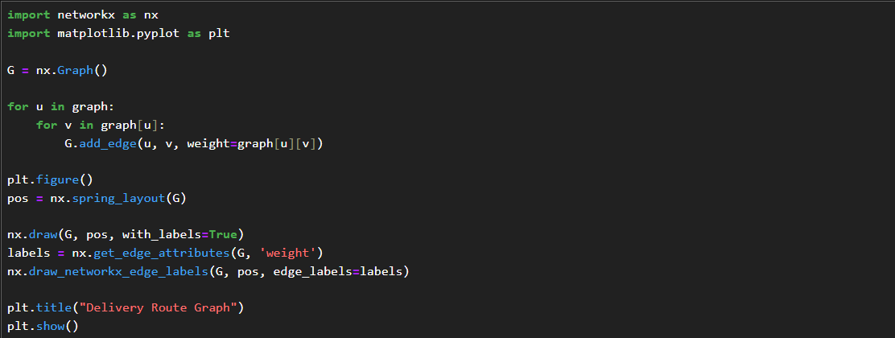
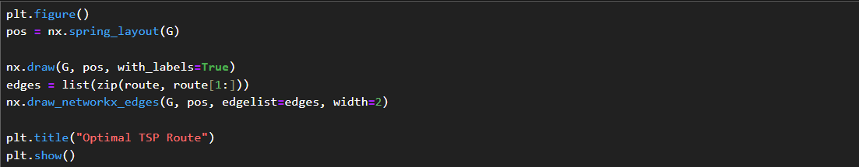
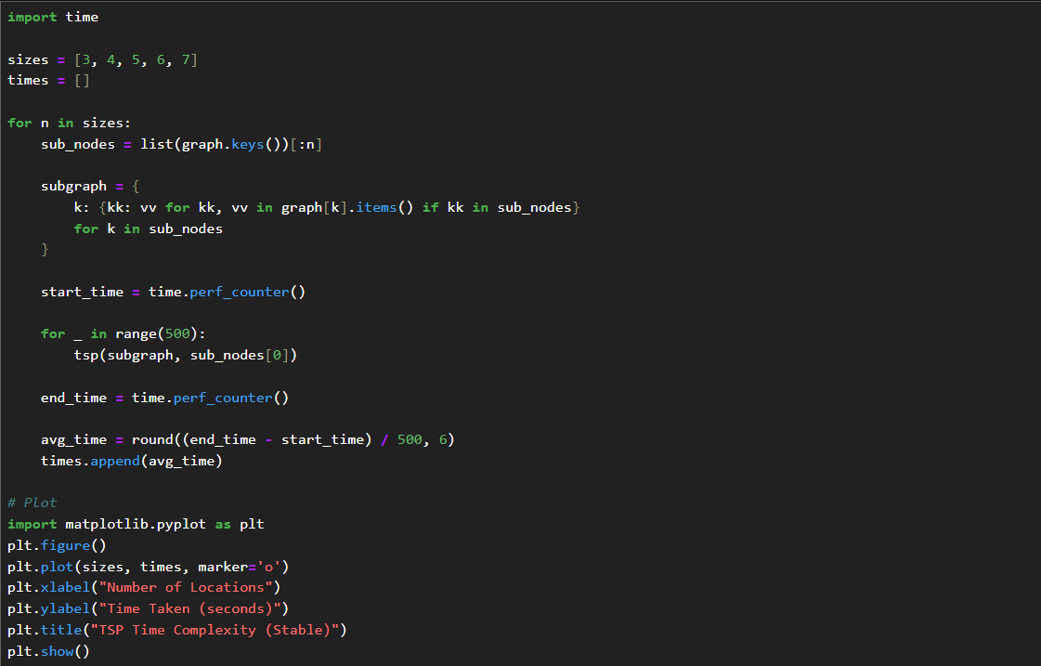

Output-
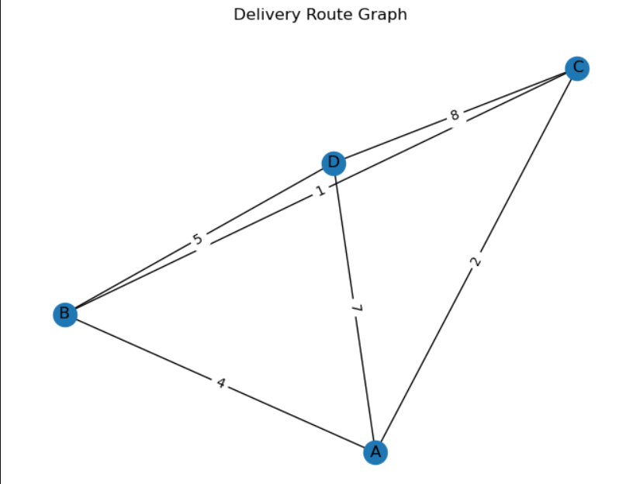

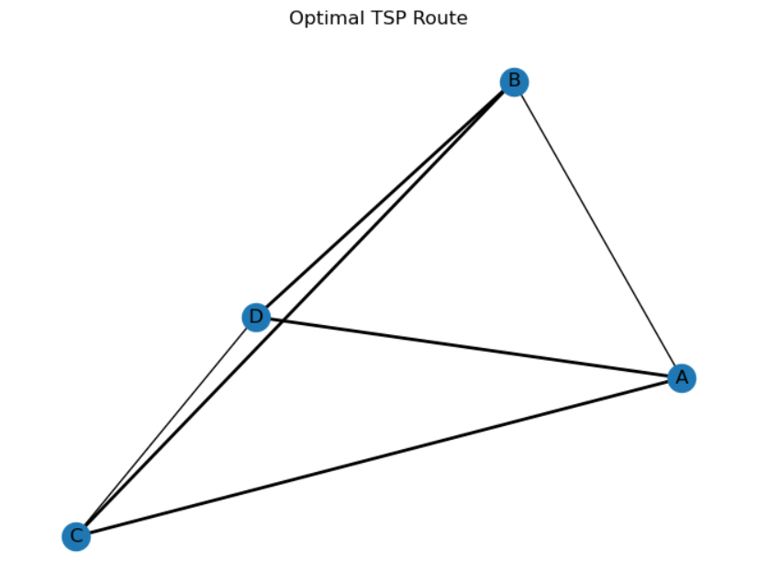

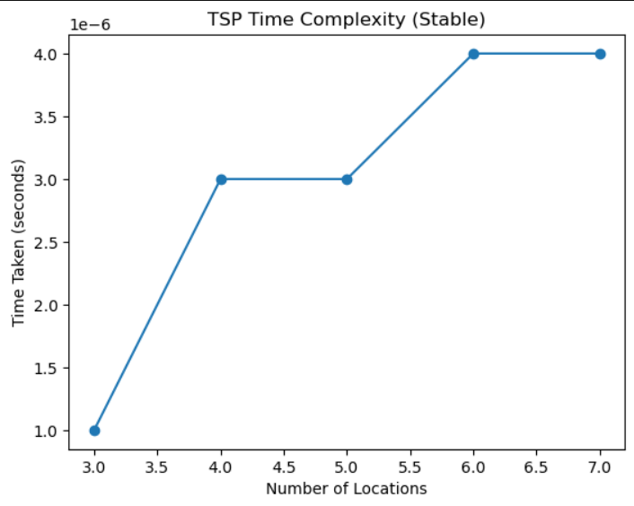

Task 7:Summary table and documentation

Algorithm | Purpose | Output | Time Complexity | Advantages | Limitations
Recurrence (Route Cost) | Calculate total path cost recursively | Total route cost | O(n) | Simple and easy to implement | Not efficient for large paths
Greedy Algorithm | Select parcels based on value/weight ratio | Selected parcels, total value | O(n log n) | Very fast and efficient | May not give optimal solution
Dynamic Programming (DP) | Validate delivery constraints (time windows) | Feasibility (True/False) | O(n × t) | Handles constraints effectively | Higher memory usage
Dijkstra Algorithm | Find shortest path from source | Shortest distance to all nodes | O(E log V) | Efficient for large graphs | Single-source only
Minimum Spanning Tree (MST) | Connect all nodes with minimum cost | Set of edges + total cost | O(E log V) | Reduces overall connection cost | Not always optimal for routing
TSP (Brute Force) | Find optimal delivery route | Best route + minimum distance | O(n!) | Gives optimal solution | Not scalable (NP-hard)

Reflection & Discussion

1.Optimization vs Realism
The TSP algorithm provided an optimal route that minimized total travel distance. However, this optimal route did not always align with real-world constraints such as delivery deadlines and vehicle capacity.
To address this, a combination of Greedy and scheduling logic was used to ensure that selected parcels could be delivered within their time windows. This showed that while TSP gives an optimal mathematical solution, it must be integrated with constraint-handling techniques to be practically useful.

2.Algorithm Trade-offs
Different algorithms showed different strengths:
Greedy Algorithm
- Fast and efficient for parcel selection
- Based on value-to-weight ratio
- May miss globally optimal combinations
Scheduling Logic (DP-based approach)
- Ensures deliveries meet deadlines
- Improves realism of solution
- Slightly increases complexity
Graph Algorithms (Dijkstra)
- Efficiently computes shortest paths
- Scales well for larger graphs
- Does not consider delivery constraints

3. NP-hard Challenge (TSP Scalability)
The TSP implementation used a brute-force approach, which has factorial time complexity.
From the time complexity graph:
- Execution time increased as the number of locations increased
- Even with small inputs (3–7 nodes), the trend showed growth
- The graph was relatively smooth due to averaging multiple runs for stability

4.Visualization Insight
Visualization played a key role in analyzing results:
Route Graph
- Showed connections between locations clearly
TSP Route Highlight
- Helped visualize the optimal delivery path
Time Complexity Graph
- Demonstrated increasing execution time with more locations
Profit vs Weight Graph
- Showed distribution of parcels
- Annotated with value-to-weight ratio to justify greedy selection

5.Feature Suggestion
To further improve realism, the following features can be added:
Multi-Vehicle Routing
- Distribute deliveries across multiple vehicles
Fuel Cost Optimization
- Include cost per distance instead of just distance
Dynamic Traffic Conditions
- Modify edge weights based on real-time traffic
Priority-Based Delivery
- Assign urgency levels to parcels

Conclusion
This project demonstrates that real-world delivery optimization cannot be solved using a single algorithmic approach. While the Traveling Salesman Problem provides an optimal route, it fails to incorporate practical constraints such as delivery deadlines and vehicle capacity. The integration of greedy techniques for parcel selection, scheduling logic for time validation, and graph algorithms for shortest path computation results in a more balanced and realistic solution. Additionally, visualization and performance analysis help in understanding algorithm behavior and scalability. Overall, this project highlights the importance of combining multiple algorithmic paradigms to effectively solve complex logistics problems.
Github Repository Link:

